Tutorial No : 4

Tutorial Title: Write a program in C++ to perform following operations on complex numbers Add, Subtract, Multiply, Divide, Complex conjugate. Design the class for complex number representation and the operations to be performed. The objective of this assignment is to learn the concepts classes and objects
Name of Student: Tejas Sachin Patil
Class: E&TC Div: SY2 PRN No: B25ET1125 Batch: C2

____________________________________________________________________________

Program 1:
#include <iostream>
using namespace std;
class numbers{
private:

double num1;
double num2;

public:
void input(){
cout<<"Enter the first number:-";
cin>> num1;
cout<<"Enter second number:-";
cin>> num2;
}
void output(){
cout << "\nThe numbers you entered are:" << endl;
cout << "First Number: " << num1 << endl;
cout << "Second Number: " << num2 << endl;
}
};
int main (){
numbers obj;
obj.input();
obj.output();

return 0;
}

Output 1:
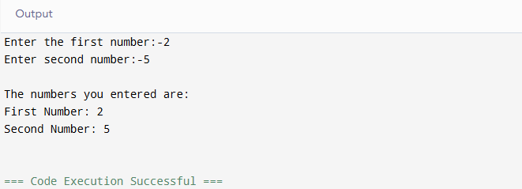
Program 2: (A+IB)
#include <iostream>
#include <cmath>
using namespace std;

class complex {
private:
double a;
double b;

public:

void input() {
cout << "Enter the real no.: ";
cin >> a;
cout << "Enter the imaginary no.: ";
cin >> b;
}

void output() {
cout << "\nThe complex number is: ";

if (b < 0) {

cout << a << " - i" << abs(b) << endl;
} else {

cout << a << " + i" << b << endl;
}
}
};

int main() {
complex c;

c.input();
c.output();

return 0;
}

Output 2:
